Common Language Infrastructure (CLI)

Partition IV:

Profiles and Libraries

The participants in ECMA TC39/TG3 are providing these working documents to the public for informational purposes only. The contents are subject to change as often as once a month. To participate in the standardization process, contact your company's ECMA representative. If your company does not currently participate in ECMA and wishes to do so, please contact ECMA (http://www.ecma.ch/) directly.
The following have participated in the work of ECMA TC39/TG3 and their contributions are gratefully acknowledged:
Fujitsu Software, Hewlett-Packard, Intel Corporation, International Business Machines, ISE, Microsoft Corporation, Monash University, Netscape, Phone.Com, Plum Hall, Sun Microsystems
Table of contents

- 1 Overview 1
- 2 Libraries and Profiles 2
  - 2.1 Libraries 2
  - 2.2 Profiles 2
  - 2.3 Structure of the Standard 3
- 3 The Standard Profiles 4
  - 3.1 The Kernel Profile 4
  - 3.2 The Compact Profile 4
- 4 Kernel Profile Feature Requirements 5
  - 4.1 Features Excluded from Kernel Profile 5
    - 4.1.1 Floating Point 5
    - 4.1.2 Non-vector Arrays 5
    - 4.1.3 Reflection 5
    - 4.1.4 Application Domains 6
    - 4.1.5 Remoting 6
    - 4.1.6 Varargs 6
    - 4.1.7 Frame Growth 6
    - 4.1.8 Filtered Exceptions 6
- 5 The Standard Libraries 7
  - 5.1 Runtime Infrastructure Library 7
  - 5.2 Base Class Library 7
  - 5.3 Network Library 7
  - 5.4 Reflection Library 7
  - 5.5 XML Library 7
  - 5.6 Extended Numerics Library 7
  - 5.7 Extended Array Library 8
- 6 Implementation-Specific Modifications to the System Libraries 9
- 7 Semantics of the XML Specification 10
  - 7.1 Value Types as Objects 11

- Overview
Note:
While compiler writers are most concerned with issues of file format, instruction set design, and a common type system, application programmers are most interested in the programming library that is available to them in the language they are using. The Common Language Infrastructure (CLI) specifies a Common Language Specification (CLS, see Partition I_alink_partitionI) that shall be used to define the externally visible aspects (method signatures, etc.) when they are intended to be used from a wide range of programming languages. Since it is the goal of the CLI Libraries to be available from as many programming languages as possible, all of its functionality is available through CLS-compliant types and type members.
The CLI Libraries are designed with the following goals in mind:
- Wide reach across programming languages
- Consistent design patterns throughout
- Features on parity with the ISO C library of 1990
- Features for more recent programming paradigms, notably networking, XML, runtime type inspection, instance creation, and dynamic method dispatch
- Factoring into self-consistent libraries with minimal interdependence
This document provides an overview of the CLI Libraries and a specification of their factoring into Profiles and Libraries. A companion document, distributed in XML format, provides details of each class, value type, and interface in the CLI Libraries. While the normative specification of the CLI Libraries is in XML form, it can be processed using an XSL transform to produce easily browsed information about the Class Libraries
Partition V_alink_partitionV contains an informative annex describing programming conventions used in defining the CLI Libraries. These conventions, while not normative, can significantly simplify the use of libraries. Implementers are encouraged to follow them when creating additional (non-Standard) Libraries.
- Libraries and Profiles
Libraries and Profiles, defined below, are constructs created for the purpose of standards conformance/compliance. They specify a set of features that shall be present in an implementation of the Common Language Infrastructure (CLI) and a set of types that shall be available to programs run by that CLI.
Note: There need not be any direct support for Libraries and Profiles in the Virtual Execution System (VES). They are not represented in the metadata and they have no impact on the structure or performance of an implementation of the CLI. Libraries and Profiles may span assemblies (the deployment unit), and the names of types in a single Library or Profile are not required to have a common prefix (“namespace”).
There is, in general, no way to test whether a feature is available at runtime, nor a way to enquire whether a particular Profile or Library is available. If present, however, the Reflection Library makes it possible to test at runtime for the existence of particular methods and types.
  - Libraries
A Library specifies three things:
- A set of types that shall be available, including their grouping into assemblies.
- A set of features of the CLI that shall be available.
- Note: The set of features required for any particular Library is a subset of the complete set of CLI features. Each Library described in Chapter 13_5_The_Standards_Library has text that defines what CLI features are required for implementations that support the Library.
- Modifications to types defined in other Libraries. These modifications are typically the addition of methods and interfaces to types belonging to the other Library, and additional exceptions that may be thrown by methods of the other Library’s types. These modifications shall provide only additional functionality or specify behavior where it was previously unspecified; they shall not be used to alter previously specified behavior.
Example (informative): Consider the Extended Numerics Library. Since it provides a new base data type, Double, it also specifies that the method ToDouble be added to the System.Convert class that is part of the Base Class Library. It also defines a new exception, System.NotFiniteNumberException, and specifies existing methods in other Libraries methods that throw it (as it happens, there are no such methods).
In the XML specification of the Libraries, each type specifies the Library to which it belongs. For those members (e.g., Console.WriteLine(float)) that are part of one Library (Extended Numerics) but whose type is in another Library (BCL), the XML specifies the Library that defines the method. See Chapter 15_7_Semantics_of_the_XML_Specification.
  - Profiles
A Profile is simply a set of Libraries, grouped together to form a consistent whole that provides a fixed level of functionality. A conforming implementation of the CLI shall specify a Profile it implements, as well as any additional Libraries that it provides. The Kernel Profile (see Section 11.1_3.1_The_Kernel_Profile) shall be included in all conforming implementations of the CLI. Thus, all Libraries and CLI features that are part of the Kernel Profile are available in all conforming implementations. This minimal feature set is described in Chapter Error: Reference source not found_4_Kernel_ProfileFeature_Requirements.
Rationale: The rules for combining Libraries together are complex, since each Library may add members to types defined in other libraries. By standardizing a small number of Profiles we specify completely the interaction of the Libraries that are part of each Profile. A Profile provides a consistent target for vendors of devices, compilers, tools, and applications. Each Profile specifies a trade-off of CLI feature and implementation complexity against resource constraints. By defining a very small number of Profiles we increase the market for each Profile, making each a desirable target for a class of applications across a wide range of implementations and tool sets.
  - Structure of the Standard
This standard specifies two Standard Profiles (see Chapter 11_The_Standards_Profile) and 7 Standard Libraries (see Chapter 13_5_The_Standards_Library). The following diagram shows the relationship between the Libraries and the Profiles:
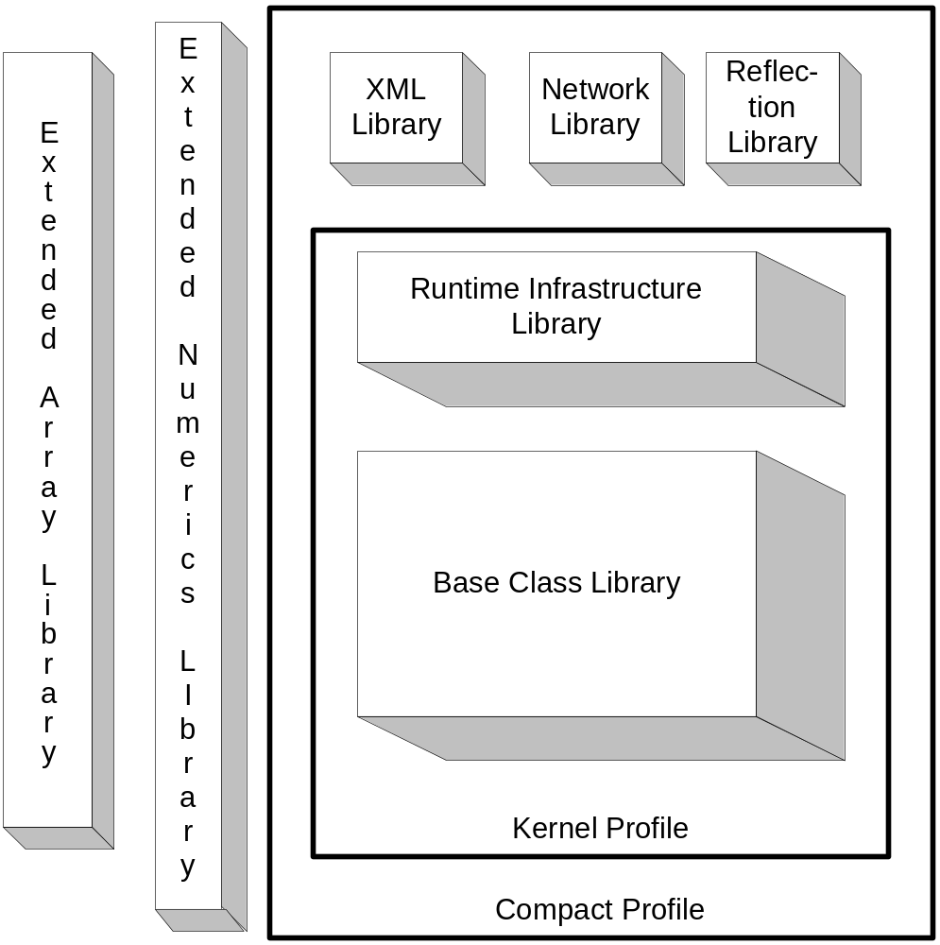
The Extended Array Library and the Extended Numerics Library are not part of either Profile, but may be combined with either of them. Doing so adds the appropriate methods, exceptions, and interfaces to the types specified in the Profile.
- The Standard Profiles
There are two Standard Profiles. The smallest conforming implementation of the CLI is the Kernel Profile, while the Compact Profile contains additional features useful for applications targeting a more resource-rich set of devices.
A conforming implementation of the CLI shall throw an appropriate exception (for example, System.Not-ImplementedException, System.MissingMethodException, or System.ExecutionEngineException) when it encounters a feature specified in this Standard but not supported by the particular Profile (see Partition III_alink_partitionIII).
Note: Implementers should consider providing tools that statically detect features they do not support so users have an option of checking programs for the presence of such features before running them.
Note: Vendors of compliant CLI implementations should specify exactly which configurations of Standard Libraries and Standard Profiles they support.
Note: “Features” may be something like the use of a floating point CIL instruction in the implementation of a method when the CLI upon which it is running does not support the Extended Numerics Library. Or, the “feature” might be a call to a method that this Standard specifies exists only when a particular Library is implemented and yet the code making the call is running on an implementation of the CLI that does not support that particular library.
  - The Kernel Profile
This profile is the minimal possible conforming implementation of the CLI. It contains the types commonly found in a modern programming language class library plus the classes needed by compilers targeting the CLI.
Contents: Base Class Library, Runtime Infrastructure Library
  - The Compact Profile
This Profile is designed to allow implementation on devices with only modest amounts of physical memory yet provides more functionality than the Kernel Profile alone. It also contains everything required to implement the ECMAScript compact profile proposed within ECMA TC39/TG1.
Contents: Kernel Profile, XML Library, Networking Library, Reflection Library
- Kernel Profile Feature Requirements
All conforming implementations of the CLI support at least the Kernel Profile and consequently all CLI features required by the Kernel Profile must be implemented by all conforming implementations. This section defines that minimal feature set by enumerating the set of features that are not required, i.e., a minimal conforming implementation must implement all CLI features except those specified in the remainder of this section. The feature requirements of individual Libraries as specified in Chapter 13 are defined by reference to restricted items described in this section. For ease of reference, each feature has a name indicated by the name of the section heading. Where Libraries do not specify any additional feature requirement, it shall be assumed that only the features of the Kernel Profile as described in this Section are required.
  - Features Excluded from Kernel Profile
The following internal data types and constructs, specified elsewhere in this Standard, are not required of CLI implementations that conform only to the Kernel Profile. All other CLI features are required.
    - Floating Point
The floating point feature set consists of the user-visible floating-point data types float32 and float64, and support for an internal representation of floating-point numbers.
If omitted: The CIL instructions that deal specifically with these data types throw the System.NotImplementedException exception. These instructions are: ckfinite, conv.r.un, conv.r4, conv.r8, ldc.r4, ldc.r8, ldelem.r4, ldelem.r8, ldind.r4, ldind.r8, stelem.r4, stelem.r8, stind.r4, stind.r8. Any attempt to reference a signature including the floating-point data types shall throw the System.NotImplementedException exception. The precise timing of the exception is not specified.
Note: These restrictions guarantee that the VES will not encounter any floating-point data. Hence the implementation of the arithmetic instructions (add, etc.) need not handle those types.
Part of Library: Extended Numerics (see Section 13.6_5.6_Extended_Numerics_Library)
    - Non-vector Arrays
The non-vector arrays feature set includes the support for arrays with more than one dimension or with lower bounds other than zero. This includes support for signatures referencing such arrays, runtime representations of such arrays, and marshalling of such arrays to and from native data types.
If omitted: Any attempt to reference a signature including a non-vector array shall throw the System.NotImplementedException exception. The precise timing of the exception is not specified.
Note: The generic type System.Array is part of the Kernel Profile and is available in all conforming implementations of the CLI. An implementation that does not provide the non-vector array feature set can correctly assume that all instances of that class are vectors.
Part of Library: Extended Arrays (see Section 13.7_5.7_Extended_Array_Library).
    - Reflection
The reflection feature set supports full reflection on data types. All of its functionality is exposed through methods in the Reflection Library.
If omitted: The Kernel profile specifies an opaque type, System.Type, instances of which uniquely represent any type in the system and provide access to the name of the type.
Note: With just the Kernel profile there is no requirement, for example, to determine the members of the type, dynamically create instances of the type, or invoke methods of the type given an instance of System.Type. This can simplify the implementation of the CLI compared to that required when the Reflection Library is available.
Part of Library: Reflection (see Section Error: Reference source not found_5.4_Reflection_Library).
    - Application Domains
The application domain feature set supports multiple application domains. The Kernel profile requires that a single application domain exist.
If omitted: Methods for creating application domains (part of the Base Class Library, see Section 13.2_5.2_Base_Class_Library) throw the System.NotImplementedException exception.
Part of Library: (none)
    - Remoting
The remoting feature set supports remote method invocation. It is provided primarily through special semantics of the class System.MarshalByRefObject as described in Partition I_alink_PartitionI.
If omitted: The class System.MarshalByRefObject shall be treated as a simple class with no special meaning.
Part of Library: (none)
    - Varargs
The varargs feature set supports variable length argument lists and runtime typed pointers.
If omitted: Any attempt to reference a method with the varargs calling convention or the signature encodings associated with varargs methods (see Partition II_alink_PartitionII) shall throw the System.NotImplementedException exception. Methods using the CIL instructions arglist, refanytype, mkrefany, and refanyval shall throw the System.NotImplementedException exception. The precise timing of the exception is not specified.
Part of Library: (none)
    - Frame Growth
The frame growth feature set supports dynamically extending a stack frame.
If omitted: Methods using the CIL localloc instruction shall throw the System.NotImplementedException exception. The precise timing of the exception is not specified.
Part of Library: (none)
    - Filtered Exceptions
The filtered exceptions feature set supports user-supplied filters for exceptions.
If omitted: Methods using the CIL endfilter instruction or with an exceptionentry that contains a non-null filterstart (see Partition I_alink_PartitionI) shall throw the System.NotImplementedException exception. The precise timing of the exception is not specified.
Part of Library: (none)
- The Standard Libraries
The detailed content of each Library, in terms of the types it provides and the changes it makes to types in other Libraries, is provided in XML form. This section provides an informative description of each Library’s purpose as well as specifying the features of the CLI required by each Library beyond those required by the Kernel Profile.
  - Runtime Infrastructure Library
The Runtime Infrastructure Library is part of the Kernel Profile. It provides the services needed by a compiler to target the CLI and the facilities needed to dynamically load types from a stream in the file format specified in Partition II_alink_partitionII. For example, it provides System.BadImageFormatException, which is thrown when a stream that does not have the correct format is loaded.
CLI Feature Requirement: None
  - Base Class Library
The Base Class Library is part of the Kernel Profile. It is a simple runtime library for a modern programming language. It serves as the Standard for the runtime library for the language C# (referenced by ECMA TC39/TG2) as well as one of the CLI Standard Libraries. It provides types to represent the built-in data types of the CLI, simple file access, custom attributes, security attributes, string manipulation, formatting, streams, collections, and so forth.
CLI Feature Requirement: None
  - Network Library
The Network Library is part of the Compact Profile. It provides simple networking services including direct access to network ports as well as HTTP support.
CLI Feature Requirement: None
  - Reflection Library
The Reflection Library is part of the Compact Profile. It provides the ability to examine the structure of types, create instances of types, and invoke methods on types, all based on a description of the type.
CLI Feature Requirement: Must support Reflection, see Section 13.1_5.1_Runtime_Infrastructure_Library.
  - XML Library
The XML Library is part of the Compact Profile. It provides a simple “pull-style” parser for XML. It is designed for resource-constrained devices, yet provides a simple user model. A conforming implementation of the CLI that includes the XML Library shall also implement the Network Library (see Section 13.3_5.3_Network_Library).
CLI Feature Requirement: None
  - Extended Numerics Library
The Extended Numerics Library is not part of any Profile, but can be supplied as part of any CLI implementation. It provides the support for floating-point (System.Single, System.Double) and extended-precision (System.Decimal) data types. Like the Base Class Library, this Library is directly referenced by the C# Standard (TC39/TG2).
Note: Programmers who use this library will benefit if implementations specify which arithmetic operations on these data types are implemented primarily through hardware support.

Rationale: The Extended Numerics Library is kept separate because some commonly available processors do not provide direct support for the data types. While software emulation can be provided, the performance difference is often so large (1,000 fold or more) that it is unreasonable to build software using floating-point operations without being aware of whether the underlying implementation is hardware-based.
CLI Feature Requirement: Floating Point, see clause Error: Reference source not found_4.1.1_Floating_Point.
  - Extended Array Library
This Library is not part of any Profile, but can be supplied as part of any CLI implementation. It provides support for non-vector arrays. That is, arrays that have more than one dimension, and arrays that have non-zero lower bounds.
CLI Feature Requirement: Non-vector Arrays, see clause Error: Reference source not found_4.1.2_Non-vector_Arrays.
- Implementation-Specific Modifications to the System Libraries
Implementers are encouraged to extend or modify the types specified in this Standard to provide additional functionality. Implementers should notice, however, that type names beginning with “System.” and bearing the special Standard Public Key are intended for use by the Standard Libraries: such names not currently in use may be defined in a future version of this Standard.
To allow programs compiled against the Standard Libraries to work when run on implementations that have extended or modified the Standard Libraries, such extensions or modifications shall obey the following rules:
- The contract specified by virtual methods shall be maintained in new classes that override them.
- New exceptions may be thrown, but where possible these should be subclasses of the exceptions already specified as thrown rather than entirely new exception types. Exceptions initiated by methods of types defined in the Standard Libraries shall be derived from System.Exception.
- Interfaces and virtual methods shall not be added to an existing interface. Nor shall they be added to an abstract class unless the class provides an implementation.
Rationale: An interface or virtual method may be added only where it carries an implementation. This allows programs written when the interface or method was not present to continue to work.
- Instance methods shall not be implemented as virtual methods.
Rationale: Methods specified as instance (non-static, non-virtual) in this standard are not permitted to be implemented as virtual methods in order to reduce the likelihood of creating non-portable files by using implementation-supplied libraries at compile time. Even though a compiler need not take a dependence on the distinction between virtual and instance methods, it is easy for a user to inadvertently override a virtual method and thus create non-portable code. The alternative of providing special files corresponding to this Standard for use at compile time is prone to user error.

Note: The following common extensions are permitted by these rules.
- Adding new members to existing types.
- Concrete (non-abstract) classes may implement interfaces not defined in this standard.
- Adding fields (values) to enumerations.
- An implementation may insert a new type into the hierarchy between a type specified in this standard and the type specified as its base type. That is, this standard specifies an inheritance relation between types but does not specify the immediate base type.

Rationale: An implementation may wish to split functionality across several types in order to provide non-standard extension mechanisms, or may wish to provide additional non-standard functionality through the new base type. As long as programs do not reference these non-standard types they will remain portable across conforming implementations of the CLI.
- Semantics of the XML Specification
The XML specification conforms to the Document Type Definition (DTD) in Figure 7-1
Figure 7-1: XML DTD
<!ATTLIST block subset CDATA #REQUIRED type CDATA #REQUIRED>
<!ATTLIST code lang CDATA #REQUIRED>
<!ATTLIST exception cref CDATA #REQUIRED>
<!ATTLIST list type CDATA #REQUIRED>
<!ATTLIST Member MemberName CDATA #REQUIRED>
<!ATTLIST MemberSignature Language CDATA #REQUIRED Value CDATA #REQUIRED>
<!ATTLIST param name CDATA #REQUIRED>
<!ATTLIST Parameter Name CDATA #REQUIRED Type CDATA #REQUIRED>
<!ATTLIST paramref name CDATA #REQUIRED>
<!ATTLIST permission cref CDATA #REQUIRED>
<!ATTLIST see cref CDATA "" langword CDATA "" qualify CDATA "" topic CDATA "">
<!ATTLIST seealso topic CDATA #REQUIRED>
<!ATTLIST Type Name CDATA #REQUIRED FullName CDATA #REQUIRED FullNameSP CDATA #REQUIRED>
<!ATTLIST TypeSignature Language CDATA #REQUIRED Value CDATA #REQUIRED>
<!ATTLIST Types Library CDATA #REQUIRED>

<!ELEMENT AssemblyCulture (#PCDATA)>
<!ELEMENT AssemblyInfo (AssemblyName, AssemblyPublicKey,
AssemblyVersion, AssemblyCulture, Attributes)>
<!ELEMENT AssemblyName (#PCDATA)>
<!ELEMENT AssemblyPublicKey (#PCDATA)>
<!ELEMENT AssemblyVersion (#PCDATA)>
<!ELEMENT Attribute (AttributeName)>
<!ELEMENT AttributeName (#PCDATA)>
<!ELEMENT Attributes (Attribute)+>
<!ELEMENT Base ((BaseTypeName)?)>
<!ELEMENT BaseTypeName (#PCDATA)>
<!ELEMENT block (#PCDATA | para | see | paramref | list | c)*>
<!ELEMENT c (#PCDATA | para | see)*>
<!ELEMENT code (#PCDATA)>
<!ELEMENT description (#PCDATA)>
<!ELEMENT Docs (#PCDATA | summary | overload | internalonly | nodoc | remarks |
param | returns | value | seealso | example | devdoc | exception |
permission)*>
<!ELEMENT example (para,(code)?,(para)?,(c)?,(code)?,(c)?,(para)?,(c)?)>
<!ELEMENT exception (#PCDATA | paramref | para | see)*>
<!ELEMENT Interface (InterfaceName)>
<!ELEMENT InterfaceName (#PCDATA)>
<!ELEMENT Interfaces (Interface)*>
<!ELEMENT item (term,(description)?)>
<!ELEMENT list ((item)*,(listheader)?,(item)*)>
<!ELEMENT listheader (term,description)>
<!ELEMENT Member ((MemberSignature)+, MemberType, (Attributes)?, ReturnValue,
Parameters, (MemberValue)?, Docs>
<!ELEMENT MemberOfPackage (#PCDATA)>
<!ELEMENT MemberSignature EMPTY>
<!ELEMENT MemberType (#PCDATA)>
<!ELEMENT MemberValue (#PCDATA)>
<!ELEMENT Members (Member)+>
<!ELEMENT overload (para)+>
<!ELEMENT para (#PCDATA | block | see | paramref | c)*>
<!ELEMENT param (#PCDATA | para | see | paramref)*>
<!ELEMENT Parameter (Attributes)?>
<!ELEMENT Parameters (Parameter)*>
<!ELEMENT paramref EMPTY>
<!-- à
<!ELEMENT permission (#PCDATA | see | block)*>
<!ELEMENT remarks (#PCDATA | para | block | c | list | code | paramref)*>
<!ELEMENT returns (#PCDATA | para | see)*>
<!ELEMENT ReturnType (#PCDATA)>
<!ELEMENT ReturnValue (ReturnType)?>
<!ELEMENT see EMPTY>
<!ELEMENT seealso EMPTY>
<!ELEMENT summary (#PCDATA | para | block | see)*>
<!ELEMENT term (#PCDATA | see | para | paramref | c)*>
<!ELEMENT ThreadingSafetyStatement (#PCDATA)>
<!ELEMENT Type ((TypeSignature)+, MemberOfPackage, AssemblyInfo,
(ThreadingSafetyStatement)?, TypeKind, Docs, Base, Interfaces,
(Attributes)?, Members)>
<!ELEMENT TypeKind (#PCDATA)>
<!ELEMENT TypeSignature EMPTY>
<!ELEMENT Types (Type)+>
<!ELEMENT value (para)>
  - Value Types as Objects
Throughout the textual descriptions of methods in the XML there are places where a parameter of type object or an interface type is expected, but the description refers to passing a value type for that parameter. In these cases, the caller shall box the value type before making the call.

